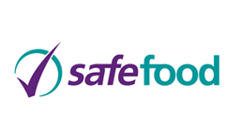
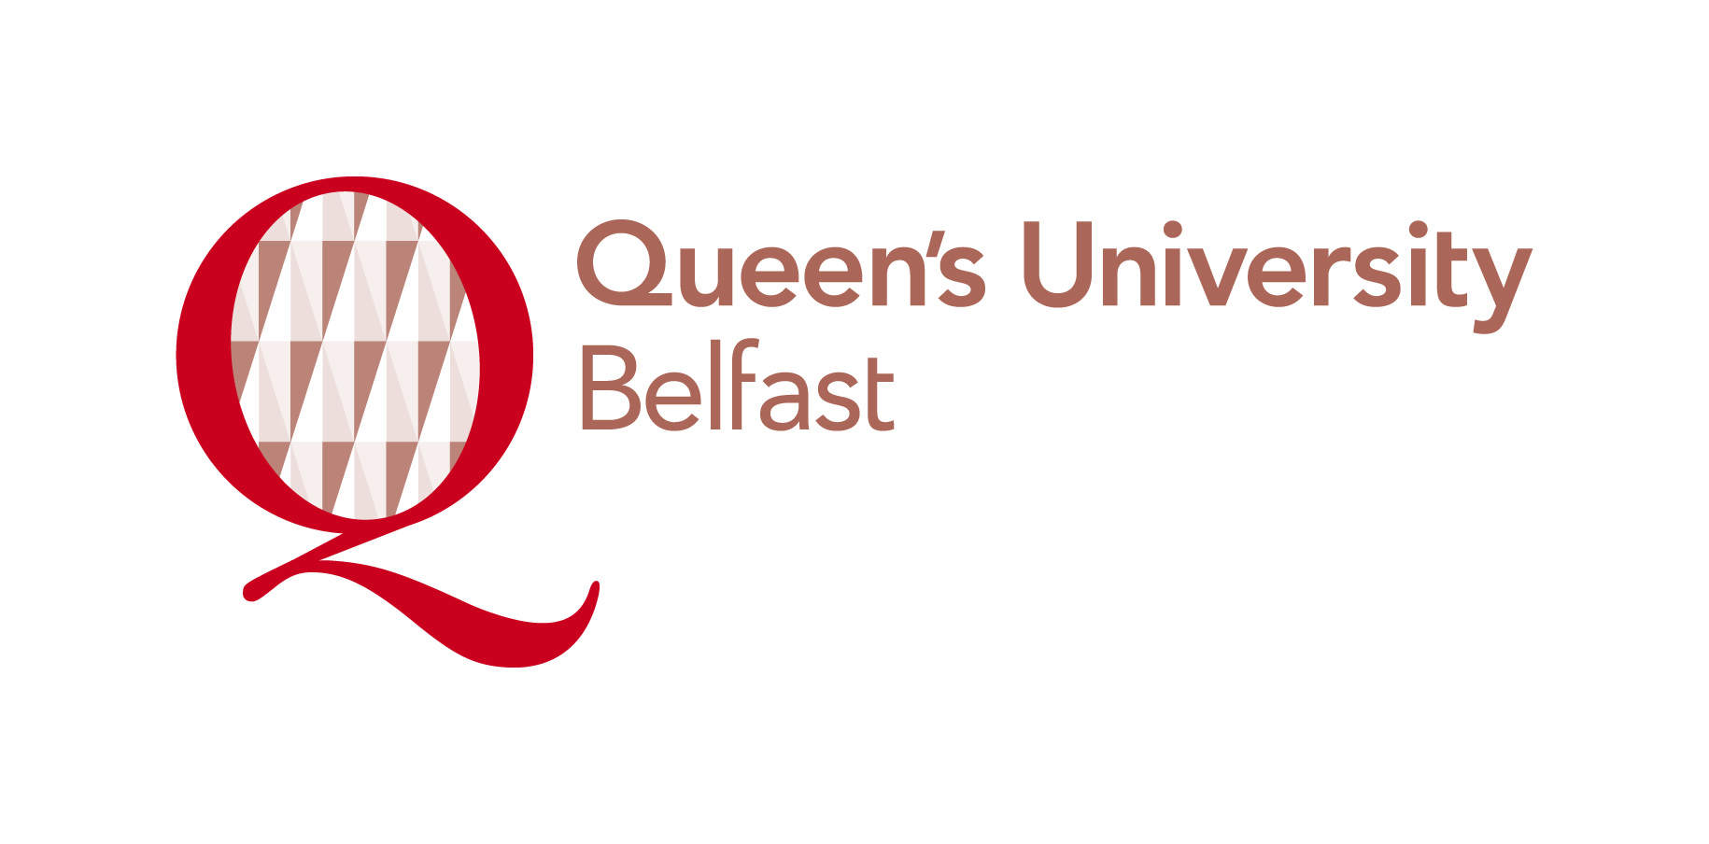

Mycotoxins and plant toxins: Emerging threats and their impact on feed and food safety

The Biotoxins in food safefood networks will hold a one day conference on the 29th November 2012 themed around ‘Mycotoxins and plant toxins: Emerging threats and their impact on feed and food safety’ at the Hilton Hotel, Belfast.

Mycotoxins and plant toxins in food and feed are considered a growing concern in food safety. The past few decades have witnessed significant scientific advances in this field especially in relation to limits and regulations for these toxins in food and feed as well as novel detection techniques for analysis and screening purposes. The widespread occurrence of these toxins and the threats posed by them demands the attention of the Biotoxins scientific community.

This conference will bring together researchers, industry and regulators across the Island of Ireland and further afield to discuss key topics of interest and concerns relating to the impact of emerging issues in relation to mycotoxins and plant toxins.

Examples of Topics

- Mycotoxins and plant toxins: Current and future concerns
- New legislation
- Animal and human exposure
- Recent advances in detection techniques
- Effect of climate change on food safety with a special focus on mycotoxins and plant toxins
- Impact on local industry

Presentation slots are available for both posters and oral presentations. Abstracts should be send to biotoxins@qub.ac.uk by Monday the 22nd of October 2012. Further details on online submissions and conference registration will be advertised shortly. The cost of participation is £50 to non-network members and free of charge to members. Membership of the Biotoxins Network is free and you can register by visiting: http://safefood.ning.com

Requests for additional information can be obtained from Prof Chris Elliott at: Chris.Elliott@qub.ac.uk

